## Stage 1: Set the project CRS

As suggested in the assignment guideline, EPSG: 25832 was set as the project CRS.

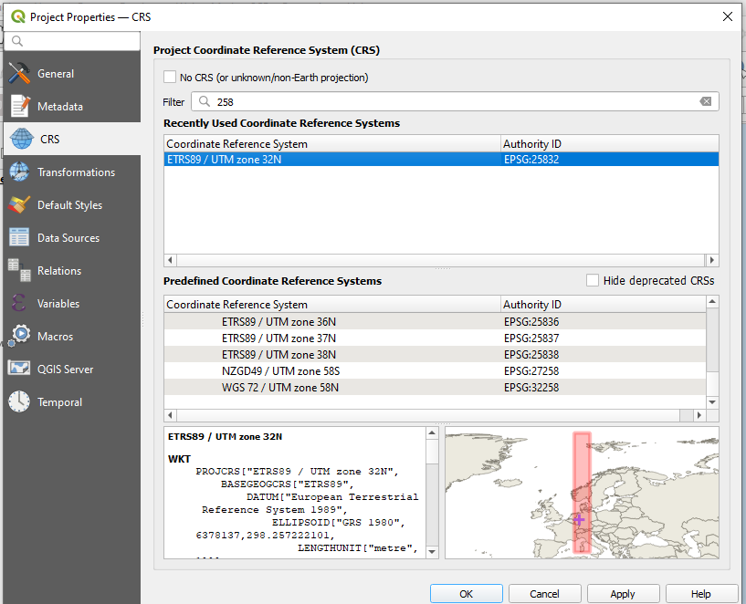

Figure : CRS set to EPSG: 25832

## Stage 2: Connect and load the WMS layer

The Digital Orthophoto layer was connected to QGIS using the [WMS URL](https://www.wms.nrw.de/geobasis/wms_nw_dop) provided by [this website](https://www.bezreg-koeln.nrw.de/brk_internet/geobasis/luftbildinformationen/aktuell/digitale_orthophotos/index.html) as mentioned in the assignment.

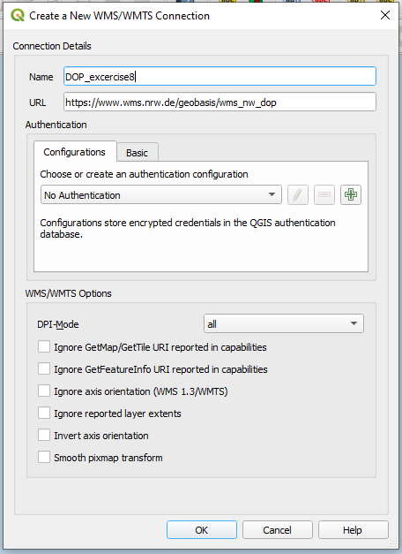

Figure : Connection to the WMS layer

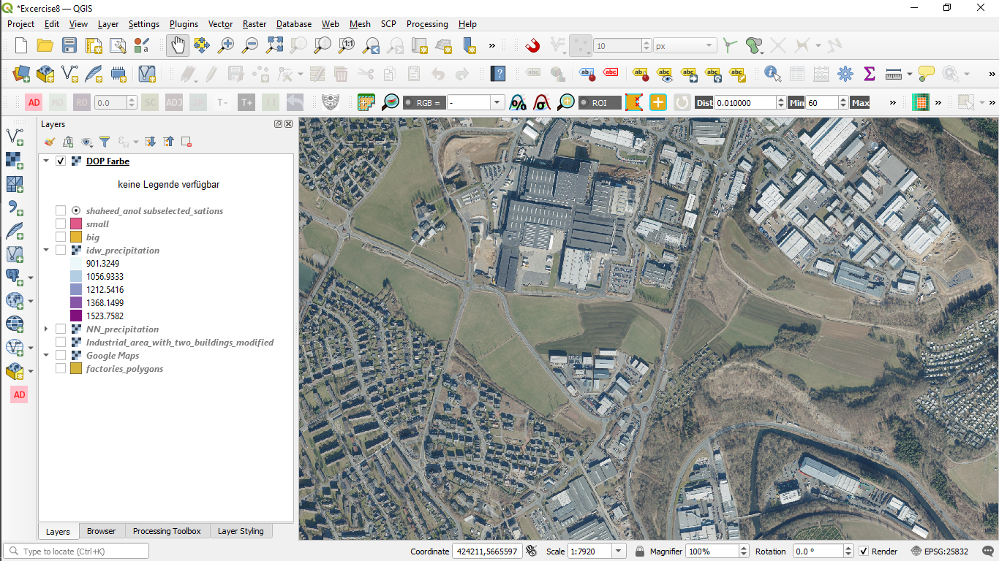

Figure WMS layer added to QGIS canvas

## Stage 3: Georeference the given screenshot

Then the “screenshot taken with a camera” was georeferenced against the WMS layer. Building corners and road junctions with sharp angles were used as the ground control points (GCPs) to ensure maximum accuracy.

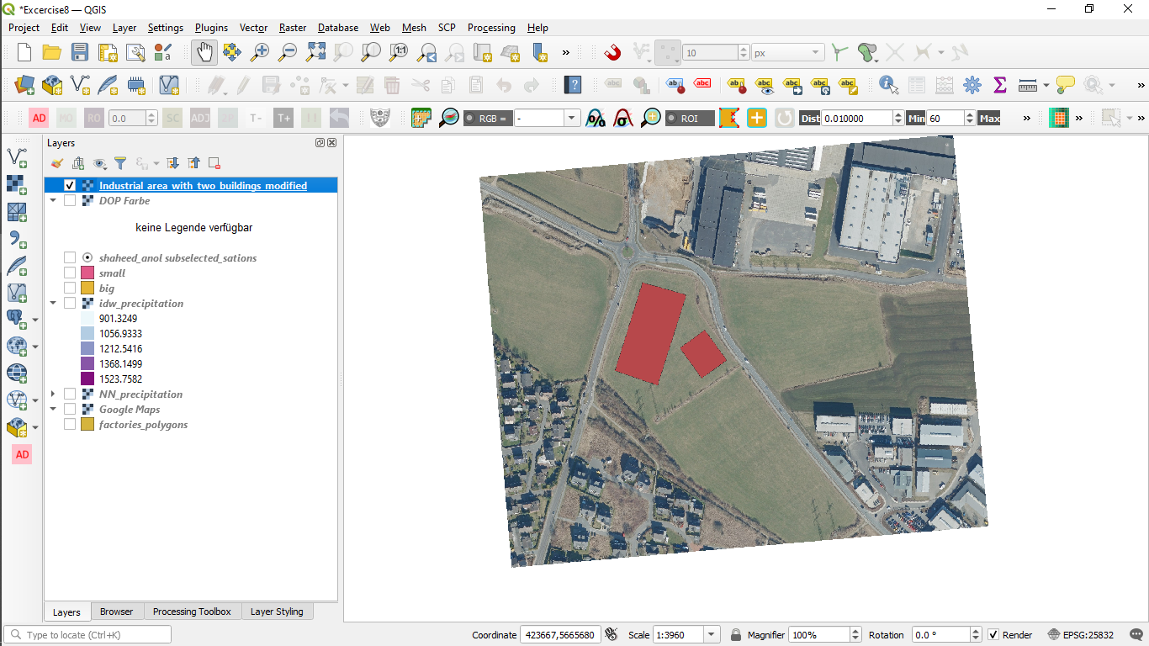

Figure : Georeferenced layer without the WMS layer

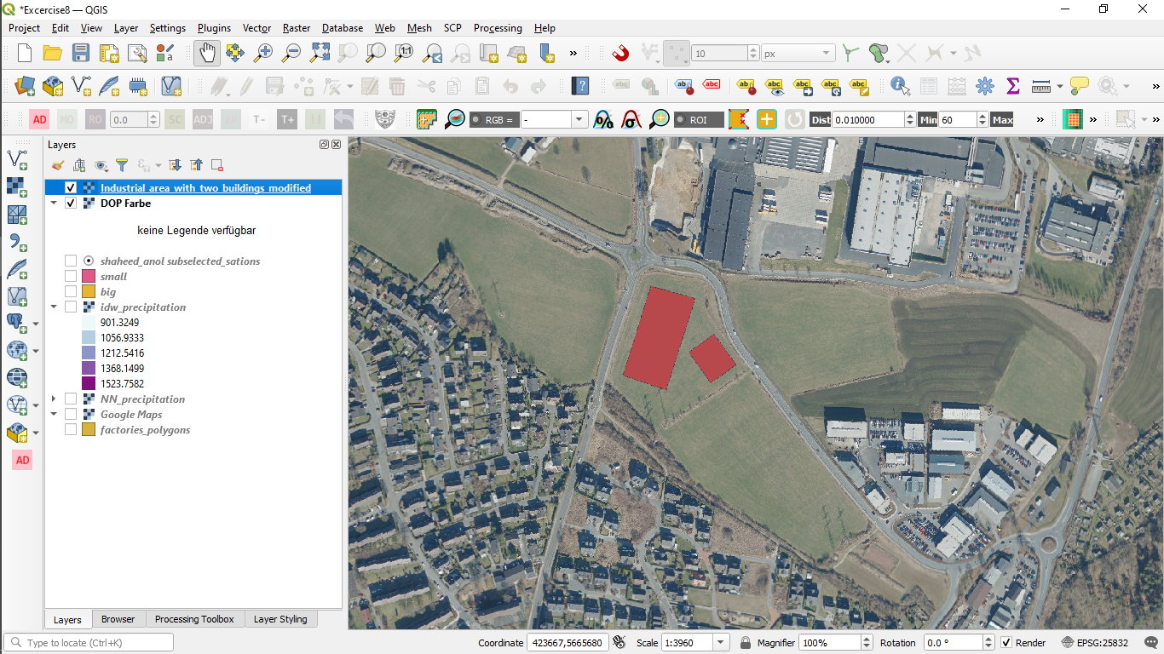

Figure Georeferenced layer blends seamlessly with WMS in background.

## Stage 4: Digitize proposed factory sites and calculate their area

Next, the two buildings were digitized into a Geopackage vector layer. The area on the left is called factory1 while the area on the right is called factory2.

Then their areas were calculated using $area function in the inbuilt QGIS field calculator. The function uses the project’s CRS unit of measurement for calculation and result. Since our project CRS uses metres as unit of measurement, the calculated areas will be in m2.

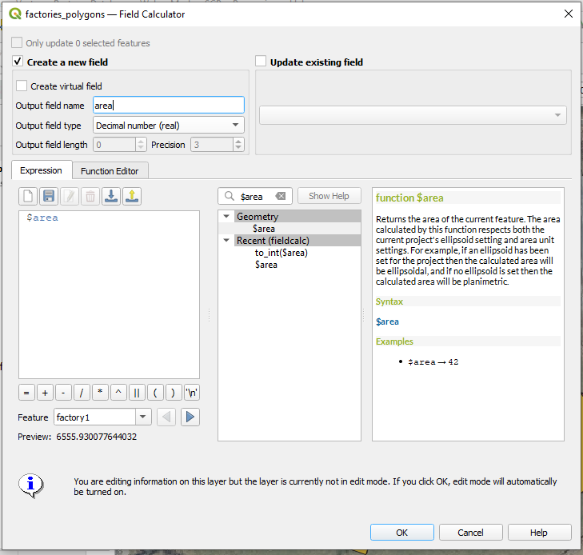

Figure : Area of proposed buildings calculated the field calculator

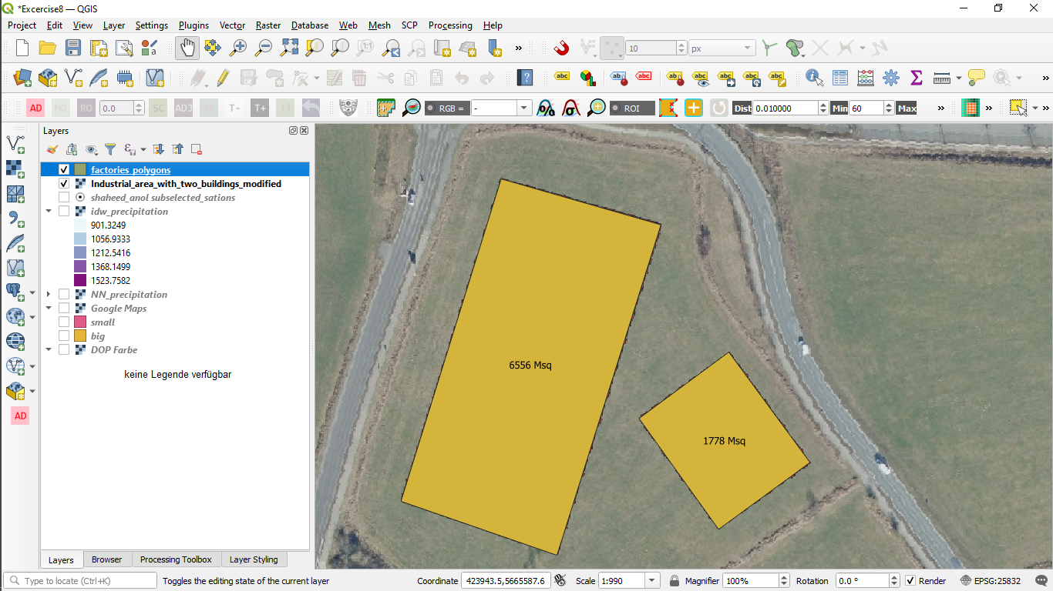

Figure : Digitized buildings labelled with their areas in M2

## Stage 5: Import weather stations CSV as points

The weather station data is a CSV file delimited with semicolons, so it was imported using the Add delimited text layer option.

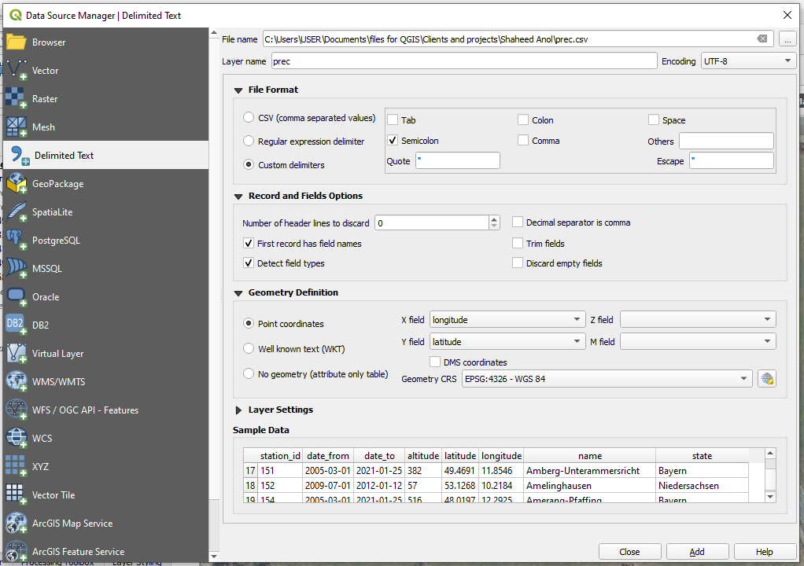

Figure : Importing precipitation CSV as point data

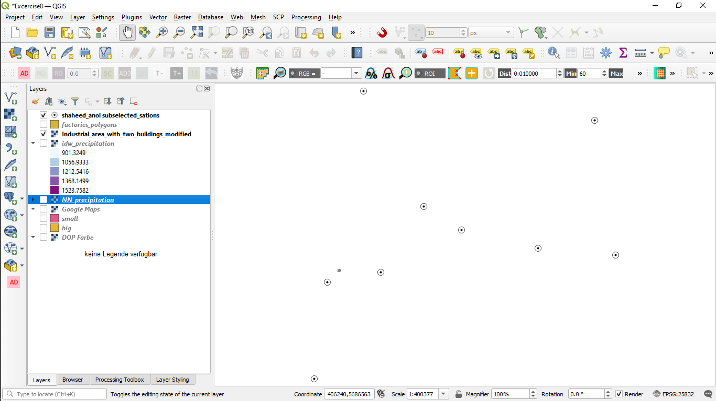

Figure : Weather stations imported as point data

## Stage 6: Add a column for the cumulative annual precipitation in the imported points

The precipitation data added in stage 5 above does not contain the amount of precipitation from each station. Another CSV file contained the precipitation data for each hour. The cumulative precipitation for the months of May to August were gotten from the second CSV, multiplied by three and then added to the attribute table of the second CSV. The Station_id column was used as the key for joining the two CSV tables.

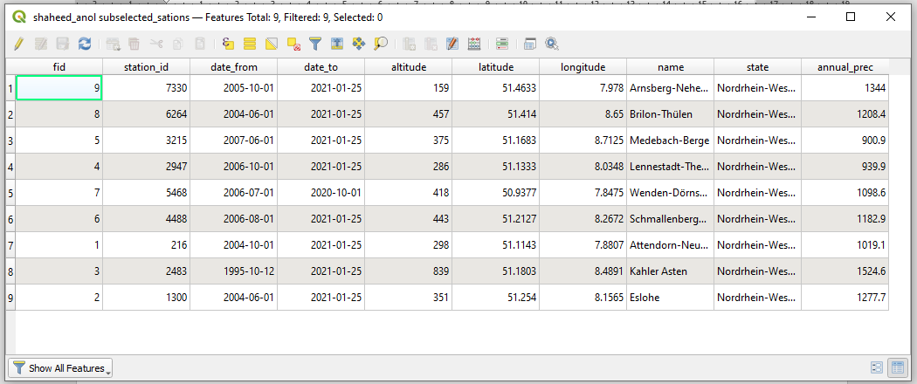

Figure : Attribute table showing the station_id (second from the left) and cummulative annual precipiation (extreme right)

## Stage 7: Interpolate the point data to get a raster layer

Since there is no weather station directly on the proposed factory site, there was need to interpolate the point data over the study area.

Two interpolation methods were used; Inverse Distance Weight (IDW) and Nearest Neighbour (NN). In both methods, the cumulative annual precipitation was used as the Z field.

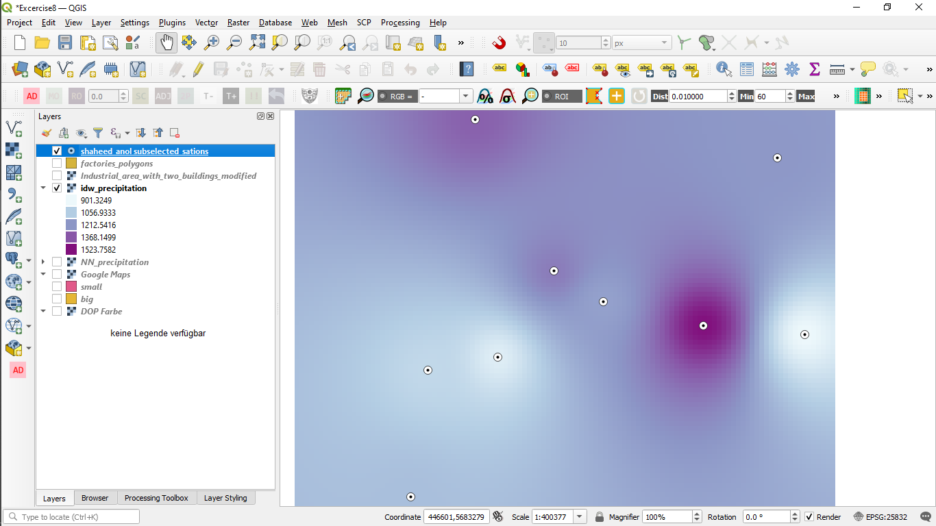

Figure : Output layer from IDW interpolation

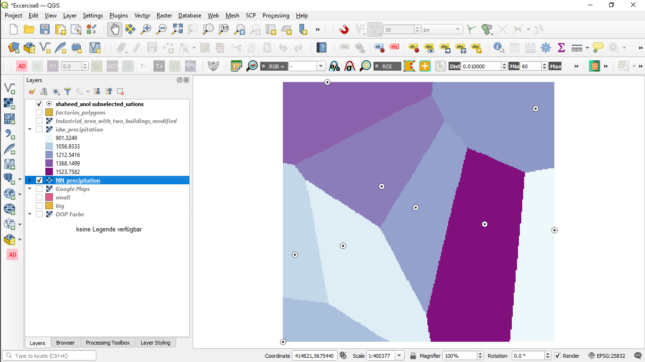

Figure : Output raster from NN interpolation

## Stage 8: use zonal statistics to get the mean annual precipitation over the area

The zonal statistics tool was used to calculate the mean pixel value of the precipitation raster layers in each building site.

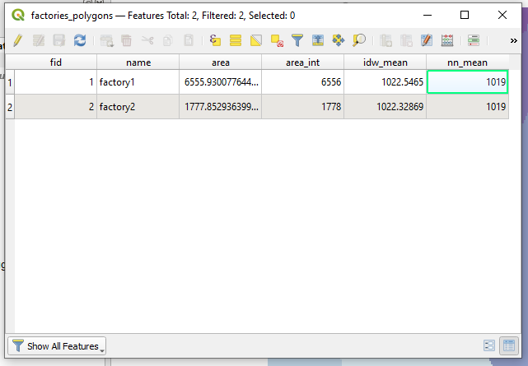

Figure : Updated attribute table showing mean precipitation for each interpolation method and each building

## Stage 9: multiply the area of the buildings by the mean annual precipitation to get final answer in m3/year.

The table below shows the area, annual precipiataion and expected volume of water per year (m3/year) for each proposed site.

|  |  |  |  |  |  |
| --- | --- | --- | --- | --- | --- |
| Factory | Area (m2) | Inverse Distance Weighted (IDW) | Nearest Neighbour (NN) | IDW collected total annual precipitation volume (m3/year) | NN collected total annual precipitation volume (m3/year) |
| Factory1 | 6556 | 1022.5465 | 1019 | 6,703,815 | 6,680,564 |
| Factory2 | 1778 | 1022.32869 | 1019 | 1,817,700 | 1,811,782 |